Lakeway Elementary Junior Troop #2487 would like you to join us in a Service Unit Event that spreads wonderful holiday cheer and provides supplies to our local food bank, Lake Travis Crisis Ministry. The girls will also earn a patch, sponsored by our fabulous Service Unit!
“Sing for their Supper” – Holiday 2018

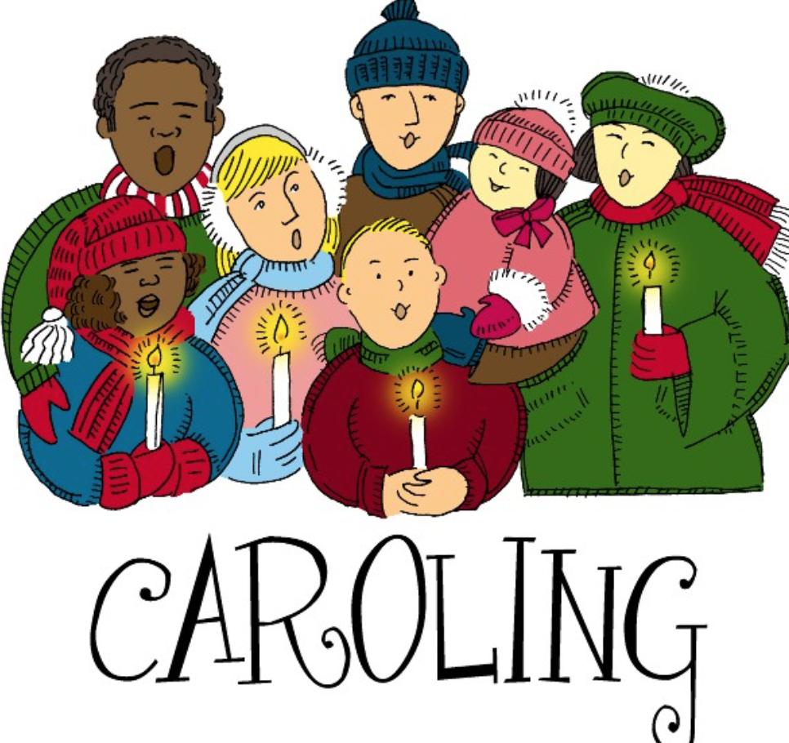

DIRECTIONS:
This project involves three components:
  - Sing Christmas carols to various homes in a designated neighborhood
    - Leave behind a flyer and paper bag describing the intent of the project
  - Return a day or two later to pick up donations
  - Deliver donations to Lake Travis Crisis Ministries on designated date/time

- Create a one-page flyer that will be dropped off at the home of which you just sang. Describe what you’re doing, who you are and who it benefits (feel free to revise template provided).
- Attach these flyers to empty paper bags (you and your troop may have plenty lying around your homes or our local grocery stores are often quite generous with donations).
- Gather your favorite Christmas Carols and practice! Note – keep it simple, especially for the younger girls.
  - you may want to consider doing this during your November troop meeting
- Arrange a date with your troop to get EVERYBODY together for a fun and festive evening in early December. Parents, neighbors, friends – the more the merrier!
  - Once you have an idea of where you will sing, sign up online (I’ll have a website) to indicate what neighborhood/streets you plan to hit – as to avoid multiple troops visiting the same homes.
- After singing at each house, thank the resident and hand the bag with flyer to that person – briefly explain what we are doing and that you will be back in 2-3 days to pick up donated items. Be sure to let them know they can simply leave the bag on their porch and you’ll grab it.
- Assign a person from your troop to sort out all the donated items into groups (canned goods, dry items, toiletries, pasta, etc.) – as it makes stocking the shelves much more efficient at the Food Bank. This is also a great task for the girls.
  - You can have a contest and see how much weight they collected, etc.
- Determine the date you’d like to drop off donated items at LTCM with your troop. LTCM is extremely grateful of our efforts and is willing to open up just for Girl Scouts to drop off items, get a brief tour, stock the shelves and a short presentation of how our efforts benefit those less fortunate than us.
  - You will have a few dates to choose from (I am working it out with LTCM) – minimum of 8 attendees/maximum of 12 (roughly). Hours will likely be 3:30-5:30pm.
  - Sign up online to reserve your preferred date and time to drop off your donation – THIS STEP IS EXTREMELY IMPORTANT! This will also help us gauge how many patches we need to order.
HELPFUL TIPS:
- Ask a music teacher, choir singer, etc. for their assistance the evening you plan to carol.
- Keep your songs simple and print out lyrics to hand out the evening of the event
- Do not sing more than 2 songs per house. People have their doors open letting in cold air and sometimes toddlers or pets try to escape, so believe me 1-2 songs will do the trick (and you’ll want to keep things moving along)
- Things to bring: musical noise makers (like jingle bells, chimes, etc.), wagons, flashlights, candles, water and light snacks. You can cue up the songs on your phone to assist with the girls and their voices. It really depends on how much you are able to practice and how big your group is. Invite others to join, as well – the more the merrier!
- Ask everybody to dress warm with appropriate shoes for walking, but to also DRESS FESTIVE: reindeer antlers, red glow noses, festive hats–this makes for great photos and adds excitement!
- Before you head out or when it’s all done, treat the girls with a warm beverage and sweet treat. In prior years, my troop will hold our Holiday Party immediately following the event!
- Have extra lyrics printed and recruit a few adults to tow the wagons and help corral the kids. Somebody following nearby in a golf cart may come in handy for those that get tired, etc.
- Rules for the kiddos: Pick a buddy and don’t leave their side, ring the door-bell when everyone is in place, a leader will assign who will ring the doorbell and who will pick the song to sing.
- You may be just caravanning with a group of moms in cars/vans from house to house. Be sure to plan how to safely get out of each car and teach the volunteer moms and the girls how that will be handled.
- For more information - http://www.ltcrisisministries.org

