

#### It’s time to try something new…there’s so much to do, see, and explore with the GSCTX Outdoors Program! What will your next adventure be?

[**Make a Difference Day at Pease Park**](https://www.gsctx.org/en/events/event-calendar.html) **Event Date: October 21, 2017** Pease Park and AmeriCorps are hosting a volunteer day on October 22nd, to make a difference on Make a Difference day! Join us at 9am at the picnic tables located along 1100 Kingsbury Street.

The activities planned are:

*Tree Mulching

*Trail Maintenance (raking and redistributing mulch, cutting back overgrown vegetation)

*Graffiti Removal and Trash Clean-Up

*Tree Planting and Wildflower Seeding

Snacks, beverages and all necessary tools will be provided to volunteers. Please be sure to wear closed-toed shoes, and be prepared for outdoor activity! Age Level: All Cost: Free Location: Austin Pease Park Deadline to register: October 16, 2017

[**Naturalist Badge with the Bull Creek Foundation**](https://www.gsctx.org/en/events/event-calendar.html) **Event Date: October 28, 2017** Age Level: Senior-Ambassador Cost: $4g, $4a Location: Bull Creek District Park Deadline to register: October 13, 2017

[**Fishing for Shade**](https://www.eventbrite.com/e/fishing-for-shade-benefiting-the-shade-project-tickets-36946453838)

**Event Date: November 4, 2017**

Age Level: Daisy-Ambassador

Cost: $20 per person (age 12 and under are free)

Location: Camp Mabry, Austin

Deadline to register: October 27,2017

[**Climbing Night on the Greenbelt**](https://www.gsctx.org/en/events/event-calendar.html) **Event Date: November 4, 2017**  Come spend an evening with Texas Climbing Adventures, their experienced, local guides know how to make sure that you gain the most from the experience. Their low guide-to-climbers’ ratio assures a great atmosphere and allows for personal instruction tailored to age and ability. Age Level: 3 grade (must be at least 8 years old) - 12 grade Cost: $45g, $45a Location: Barton Creek Greenbelt, Austin Deadline to register: October 20, 2017

[**It's My Park Day**](https://www.gsctx.org/en/events/event-calendar.html) **Event Date: November 04, 2017** Attend the city of Austins largest volunteer event, It’s My Park Day. Each year, thousands of volunteers work to improve parks and greenbelts throughout the city. Let's work together Girl Scouts and help at Bull Creek in St Edwards Park. Age Level: All Cost: Free Location: Bull Creek in St Edwards Park, Austin Deadline to register: October 30, 2017

[**Turtle Trackers**](http://www.gsctx.org/en/events/event-calendar.html) **Event Date: November 11, 2017** Explore wildlife like an expert! Use binoculars to look for birds as you go on a hike. Check out live animal demonstrations with snakes, turtles, salamanders, and alligators. The final test will be to find a wild turtle in the woods using radio tracking equipment just like the experts do. The location will be mapped with a GPS unit to help determine the range and daily movements of box turtles in the park.  Age Level: 4-12 grade Cost: $23g Location: McKinney Roughs Nature Park Deadline to register: October 28, 2017



[**Dive with Me**](http://www.gsctx.org/en/events/event-calendar.html) **Event Date: November 15, 2017** Age Level: 5 grade (must be at least 10 years old) -12 grade Cost: $40g, $40a Location: Dive World Austin Deadline to register: November 1, 2017

[**Discover Scuba: The Ocean Guardian Experience**](http://www.gsctx.org/en/events/event-calendar.html) **Event Date: November 20, 2017** Are you or  your scout interested in marine science and conservation? Try scuba! Scuba divers love the underwater world and seek to protect it as citizen scientists. Get a taste of what it is like to be a part of scuba's citizen science community through the Ocean Guardian program. Dive World Austin's instructors use the NOAA Ocean Guardian program which incorporates scuba diving and NOAA science to teach scouts about ocean conservation. Classroom time include hands on activities, videos, and conservation projects. Then, try scuba diving in our indoor heated pool. Learn to breathe and move underwater, explore marine science activities, and practice some basic skills every diver knows! Included are Discover Diving Participant Guide, rental of scuba mask, fins, snorkel, all required scuba equipment, and participation patch. Age Level: 5 grade-8 grade Cost: $80g, $80aLocation: Dive World Austin Deadline to register: November 6, 2017

[**Keep Austin Beautiful**](https://www.gsctx.org/en/events/event-calendar.html) **Event Date: December 2, 2017** Help Keep Austin Beautiful! The Blunn Creek Partnership is working on ecological restoration of the 38-acre Blunn Creek Nature Preserve. Volunteers are welcome to join one of the monthly workdays on the 1st Saturday of every month. Workdays will consist of cutting Ligustrum and stacking it in a brush pile for chipping. Wear closed-toe shoes, long pants and a long-sleeved shirt, and bring a water bottle and gloves. Parking is available along 1200 St Edwards Dr. Please meet promptly at 8:30am as it is a short hike to the working location. Age Level: 6-12 grade Cost: Free Location: Blunn Creek Nature Preserve, Austin Deadline to register: November 27, 2017

[**Tree Badge with Bull Creek Foundation**](https://www.gsctx.org/en/events/event-calendar.html) **Event Date: December 9, 2017** Age Level: 6 grade-8 grade Cost: $4g, $4a Location: Bull Creek, Upper Bull Creek Park Deadline to register: November 22, 2017



[**Dive with Me**](http://www.gsctx.org/en/events/event-calendar.html) **Event Date: December 29, 2017** Age Level: 5 grade-12 grade Cost: $40g, $40a Location: Dive World Austin Deadline to register: December 15, 2017

[**Discover Scuba: the Ocean Guardian Experience**](http://www.gsctx.org/en/events/event-calendar.html)

**Event Date: January 15, 2018**

Age Level: Junior-Cadettes (must be at least 10 years old)

Location: Dive World Austin

Deadline to register: January 3, 2018

[**Dive with Me**](http://www.gsctx.org/en/events/event-calendar.html)

**Event Date: January 24, 2018**

Age Level: 5 grade- 12 grade

Cost: $40g, $40a

Location: Dive World Austin

Deadline to register: January 10, 2018

[**Dive with Me**](http://www.gsctx.org/en/events/event-calendar.html)

**Event Date: February 2, 2018**

Cost: $40g, $40a

Location: Dive World Austin

Deadline to register: January 19, 2018

[**Discover Scuba: the Ocean Guardian Experience**](http://www.gsctx.org/en/events/event-calendar.html)

**Event Date: February 19, 2018**

Age Level: Junior-Cadette (must be at least 10 years old)

Cost: $80g, $80a

Location: Dive World Austin

Deadline to register: February 5, 2018

[**Open Water Scuba Certification (Part 1)**](http://www.gsctx.org/en/events/event-calendar.html)

**Event Date: February 10, 2018- February 11, 2018**

Age Level: Cadette-Ambassador

Cost: $224

Location: Dive World Austin

Deadline to register: January 26, 2018

[**Wilderness Survival Course!**](https://www.gsctx.org/en/events/event-calendar.html) **Event Date: March 3, 2018** Join REI Outdoor School for a wilderness survival class focusing on 3-season skills that could save your life. During this class you will learn practical tips and strategies that every outdoor traveler should know, including: emergency priorities; how to make an emergency shelter; how to locate and access drinking water; and how to make your own emergency kit with all the essentials. You will also participate in interactive scenarios to practice and hone your skills. This class is designed for anyone who spends time outdoors. Age Level: 5 grade- 12 grade Cost: $60g, $60a Location: Wild Basin Preserve, Austin Deadline to register: February 16, 2018

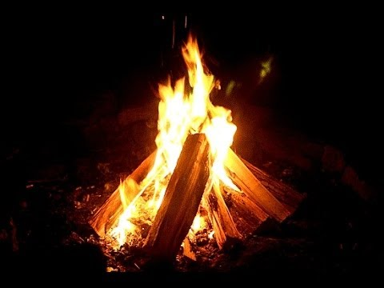

[**Open Water Scuba Certification (Part 1)**](http://www.gsctx.org/en/events/event-calendar.html)

**Event Date: March 12, 2018- March 13, 2018**

Age Level: Cadette-Ambassador

Cost: $224

Location: Dive World Austin

Deadline to register: February 26, 2018

[**Outdoor Adventure**](https://www.gsctx.org/en/events/event-calendar.html)

**Event Date: March 17, 2018**

Attend this outdoor adventure patch program and earn some requirements of the patch program. Come find out what is exciting about the outdoors as you develop your skills. Practice roll a bag relay, learn about campfire safety, pitch a tent, what a A frame is. What is your first line of shelter? What is outdoor communication?

Age Level: K-12 grade

Cost: $5g

Location: LaGrange Scout House, LaGrange

Deadline to register: March 5, 2018

[**Advanced Mariner Capri Sail**](https://www.gsctx.org/en/events/event-calendar.html) **Event Date: March 23, 2018- March 25, 2018** Have you passed your beginner sailing skills? Come join us for the weekend to work on intermediate skills and learn about larger boats. Age Level: 6 grade- 12 grade Cost: $50g, $10a Location: Camp Kachina Deadline to register: March 14, 2018

[**Discover Scuba: the Ocean Guardian Experience**](http://www.gsctx.org/en/events/event-calendar.html)

**Event Date: March 30, 2018**

Age Level: Junior-Cadette (must be at leaset 10 years old)

Cost: $80g, $80a

Location: Dive World Austin

Deadline to register: March 16, 2018

[**Advanced Mariner Weekend**](https://www.gsctx.org/en/events/event-calendar.html) **Event Date: April 6, 2018-April 8, 2018** Mariner's first sail of the year! All levels of sailors are welcome to begin or continue working on their US Sailing Small Boat sailing skills at Camp Kachina on Lake Belton. Age Level: 6 grade- 12 grade Cost: $50g, $10a Location: Camp Kachina Deadline to register: March 23, 2018

[**Zipline with Cypress Valley Canopy Tour!**](https://www.gsctx.org/en/events/event-calendar.html) **Event Date: April 8, 2018** Fly through the canopy of old growth cypress trees, some up to 100 feet tall. A new world unfolds as you glide on steel ziplines from platform to platform high in the tree tops. The tour includes 5 ziplines, 2 sky bridges, and a rappel from the last platform.

Age Level: Juniors-Ambassadors, must be at least 10 years old

Cost: $65 girl, $65 adults

Location: Spicewood, TX

Deadline to register: March 23, 2018

[**Mariner Sail Day**](https://www.gsctx.org/en/events/event-calendar.html) **Event Date: April 8, 2018** Never sail before, only a few times, or ready to refresh your skills? Then join us on beautiful Lake Belton to learn more about sailing with more experienced Mariner girls. Age Level: 5 grade- 12 grade Cost:$25g, $5a Location: Camp Kachina Deadline to register: March 23, 2018

[**Dive with Me**](http://www.gsctx.org/en/events/event-calendar.html)

**Event Date: April 11, 2018**

Age Level: 5-12 grade

Cost: $40g, $40a

Location: Dive World Austin

Deadline to register: March 28, 2018

[**Austin Clean Sweep at Bull Creek**](https://www.gsctx.org/en/events/event-calendar.html) **Event Date: April 14, 2018** Each April, Keep Austin Beautiful hosts Clean Sweep, a county-wide service day spanning 130+ sites in 31 zip codes throughout Austin and Travis County. The cleanup and project day results in over 26 tons of trash removed by 4,000 plus volunteers who contribute 8,700 combined service hours! Come help support this event by helping clean up GSCTX adopted park at St. Edwards Park, Bull Creek. Age Level: All Cost: Free Location: St. Edwards Park, Bull Creek Deadline to register: March 30, 2018

[**Outdoor Adventure**](https://www.gsctx.org/en/events/event-calendar.html)

**Event Date: April 15, 2018**

Attend this outdoor adventure patch program and earn some requirements of the patch program. Come find out what is exciting about the outdoors as you develop your skills. Practice roll a bag relay, learn about campfire safety, pitch a tent, what a A frame is. What is your first line of shelter? What is outdoor communication?

Age Level: K-12 grade

Cost: $5g

Location: Brenham

Deadline to register: April 2, 2018

[**Dive with Me**](http://www.gsctx.org/en/events/event-calendar.html)

**Event Date: April 19, 2018**

Age Level: 5-12 grade

Cost: $40g, $40a

Location: Dive World Austin

Deadline to register: April 5, 2018

[**Dive with Me**](http://www.gsctx.org/en/events/event-calendar.html)

**Event Date: April 27, 2018**

Age Level: 5 grade-12 grade

Cost: $40g, $40a

Location: Dive World Austin

Deadline to register: April 13, 2018

[**Advanced Mariner Weekend**](https://www.gsctx.org/en/events/event-calendar.html) **Event Date: April 27, 2018- April 29, 2018** Mariner's first sail of the year! All levels of sailors are welcome to begin or continue working on their US Sailing Small Boat sailing skills at Camp Kachina on Lake Belton. Age Level: 6 grade-12 grade

Cost: $50g, $10a Location: Camp Kachina Deadline to register: April 13, 2018

[**Mariner Day Sail**](https://www.gsctx.org/en/events/event-calendar.html) **Event Date: April 28, 2018**

Never sailed before, only a few times, or ready to refresh your skills? Then join us on beautiful Lake Belton to learn more about sailing with more experienced Mariner girls.

Age Level: 5 grade- 12 grade

Cost: $25g, $5a

Location: Camp Kachina

Deadline to register: April 13, 2018

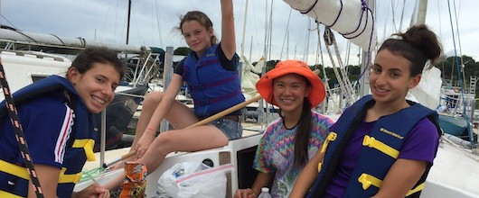

[**Horsemanship Experience**](https://www.gsctx.org/en/events/event-calendar.html) **Event Date: May 5, 2018**

TC Ranch Ventures will take you through an out of this world experience with horses. Spend a few hours with Ira and Juan as they teach you how to communicate with horses and then take your skills to new heights and try out riding for yourself! Girls will learn how to improve their communication skills to establish a relationship with the horse based on trust and respect. They learn to handle and ride horses in a responsible and safe manner. These activities help grow their confidence and to overcome fears or weak spots. It not only helps them with their emotional growth and their global personal development, but also teaches them how to always maintain a positive attitude to reach their maximum potential. Se habla espanol.

Age Level: 3 grade- 12 grade

Cost: $80g

Location: TC Ranch Ventures, Washington, TX.

Deadline to register: April 20, 2018

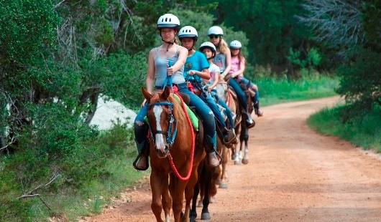

[**Discover Scuba: the Ocean Guardian Experience**](http://www.gsctx.org/en/events/event-calendar.html)

**Event Date: May 29, 2018**

Age Level: Junior-Cadette (must be at least 10 years old)

Cost: $80g, $80a

Location: Dive World Austin

Deadline to register: May 15, 2018

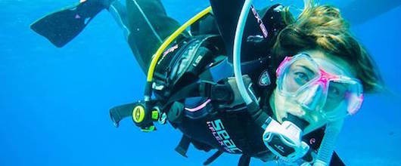

[**High Adventure Trip- Hike thru Washington DC**](https://www.gsctx.org/en/events/event-calendar.html)

**August 14, 2018-August 21, 2018**

Calling all outdoor high adventure enthusiasts! Travel to Washington DC. with us and camp at the amazing Shenandoah National Park and see cascading waterfalls, spectacular vistas, and quiet wooded hollows. Shenandoah National Park has over 500 miles of trails, including 101 miles of the Appalachian Trail. Some trails lead to a waterfall or viewpoint; others penetrate deep into the forest and Wilderness. Shenandoah is a playground for high adventure. We will also travel to Washington DC to do some site seeing to the National Mall and monuments.

Age Level: 6 grade- 12 grade

Deadline to register: June 30, 2018

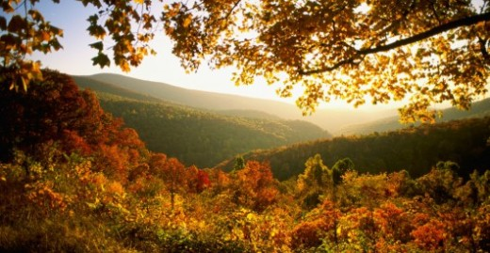

[**West Coast National Park High Adventure Trip**](https://www.gsctx.org/en/events-repository/2019/west_coast_national_.html)

**July 28, 2019- August 10, 2019**

Let's go to California! Join us on this high adventure experience in California as we explore everything we can each day. We will hike thru the Muir Woods and the Redwood Forest. We will check out the ocean and camp out under the stars-which will be customizable to girls ideas and wants prior to the trip. See the lights of Sutro Tower, smell the ocean, and hear the owls in their Cypress roosts. It's easy to see why people have been sleeping under the stars – fog-shrouded as they may be at times – here for generations, beginning with the Ohlone, the first inhabitants of this area. Take a hiking tour, site see, explore the Muir beach overlook, and so much more!

Age Level: 6 grade - 12 grade

Deadline to register: January 31, 2019

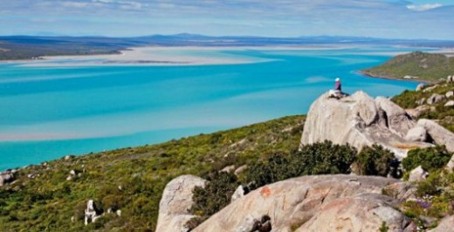

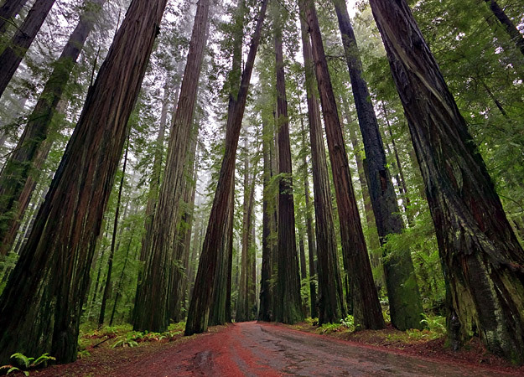

**Register for all events online:** [**http://www.gsctx.org/en/events/event-calendar.html**](http://www.gsctx.org/en/events/event-calendar.html)

(Revised 10-05-2017 C.S.)